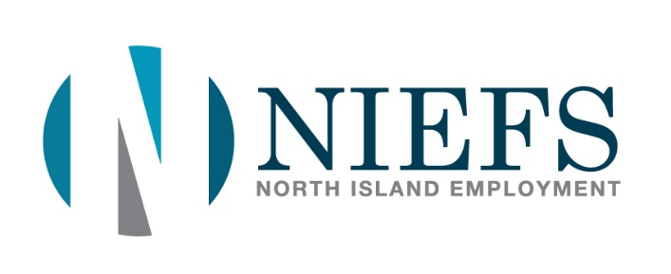
Communicable Disease Plan

Introduction:
North Island Employment Foundation Society has created a Communicable Disease Plan that outlines the policies, guidelines, and procedures they have put in place to reduce the risk of COVID-19 transmission. This plan follows the guidelines, recommendations and protocols administered by the BC Government, Provincial Health Officer, BC Centre for Disease Control, World Health Organization and WorkSafe BC on returning to safe operation as per BC’s Restart: A Plan to Bring Us Back Together.
Our Communicable Disease Plan identifies protocols that everyone at the workplace must follow to keep staff and clients safe. These protocols are to be considered and implemented to the extent that they address the risks in our workplace. At any time we may need to identify and implement additional protocols if the protocols suggested here do not sufficiently address the risk to staff and clients. This will be monitored and actioned through daily conversations with staff as well as when recommendations are made by Public Health during daily Public Health briefings.

Communicable Disease:

A communicable disease is an illness caused by an infectious agent or its toxic product that can be transmitted in a workplace from one person to another. Examples of communicable disease that may circulate in a workplace include: COVID-19, norovirus, and seasonal influenza.

Understanding the Plan:

Moving into Stage 3 of the BC Restart Plan, our sector will transition from our COVID-19 Safety Plan towards a Communicable Disease plan following guidance BC Government, Provincial Health Officer, BC Centre for Disease Control, World Health Organization and WorkSafe BC on returning to safe operation.
Our Communicable Disease Plan follows a four-step process follows ongoing measures to reduce the risk of communicable disease for when there’s an elevated risk of communicable disease.
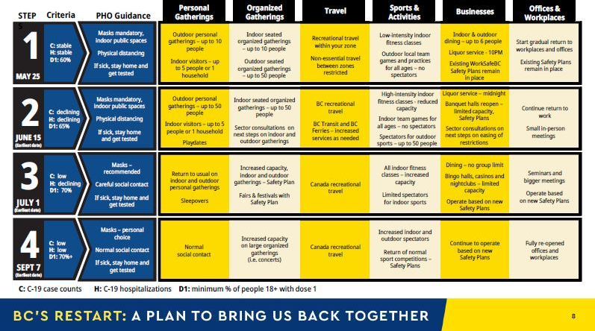

Communicable Disease Prevention:
Following our Communicable Disease Plan, NIEFS will utilize a four-step process to help manage communicable disease at our workplace.
Step 1: Understanding the Risk:
Preventing communicable disease involves taking ongoing measures to reduce the risk of communicable disease transmission in our workplace. NIEFS will implement additional measures when advised to do so by Public Health during periods of elevated risk.
The level of risk of certain communicable diseases including COVID-19, may increase from time to time or on a seasonal basis. This may occur at a local or regional level.
NIEFS will monitor and review communicable disease-related informtion issued by Island Health and the Public Health Officer. If it the information is Industry, region or workplace specific this will include following orders, guiadance, notices and recommenations as issued by Public Heath or WorkSafe BC.

Step 2: Implement meansures, practices and policies to reduce the risk:
NIEFS will implement and maintain the following measures at all times:
- Implement policies to support our staff who have symptoms of communicable disease (i.e.: fever or chills, coughing, diarrhea) so staff will stay at home when sick.
- NIEFS provides hand sanitizer and sanitizing stations in conjunction with signage reminding staff to wash their hands and to cover coughs and sneezes.
- NIEFS will maintain a clean environment through routine cleaning processes before and after Client appointments and when communal items are used by staff or clients.
- Our workplace offers a superior HVAC/Ventilation system that is properly maintained and is functioning as designed.
- NIEFS supports staff in receiving vaccinations for COVID-19 and other vaccine-preventable conditions.
- NIEFS will continue to follow all direction from medical health officials and our regional health authority.
- NIEFS will continue to follow all orders, guidance, recommendations and notices issued by the Provincial Health Officer that are relevant to our Industry (Offices, In-person Counselling), region or workplace.

Step 3: Communicate measures, practices and policies:
All Staff, Clients and Visitors entering this workplace will receive information on our communicable disease measures, practices and policies.
NIEFS will ensure all staff understand the measures we have in place and will provide information on procedures for staying home when sick.
NIEFS has posted signage throughout the office to support the measures in place and update Staff as necessary to communicate changes or updates to communicable disease protocols.

Step 4: Monitor your workplace and update your plan as necessary:
NIEFS commits to continuously evaluating and updating our plan to reflect the changing risk levels and work practices:
- NIEFS will continue to monitor the guidance, notices, orders and recommendations from Public Health Officials as required and will adjust our plan as necessary.
- NIEFS will monitor the workplace and risk level and will continue to change or modify measures, practices and policies as necessary.
- Our plan will be updated as needed to reflect changes in the workplace; including work processes, staff and premises.
- When identifying and resolving communicable & safety issues, to involve our Occupational Health and Safety Committee.

